Committee Minutes 16th February 2022

Attendees:

* Tim Bannerjee (Vice Chairman)
* Gary Couzens (Treasurer)
* Melanie Gibbs (Membership Secretary)
* Tony Braimbridge (Facilities Manager)
* Peter Gray (Squash Manager & Website)
* Graeme Hogarth (Squash Secretary)
* Danielle Wade (Operations Manager)
* Alex Kaminski (Tennis Head Coach)
* Marco Spinola (Squash Head Coach)

Apologies

* Murray Sutton (Chairman)
* Sarah Dickinson (Social Secretary)

# Agenda

* Finances
* Membership Levels
* 2022 Investment priorities update; Squash Building, Tennis Floodlights, Drainage
* Head Coach Updates
* Rebuilding the Social Calendar

# Finances

These continue to move in an extremely positive direction with all revenue streams ending 2021 trending positive Vs post pandemic 2019.

* Bank Balance; £170K
* Loans: £20K
* Major Invoices due; £5K

The trend of the main club revenue streams is below

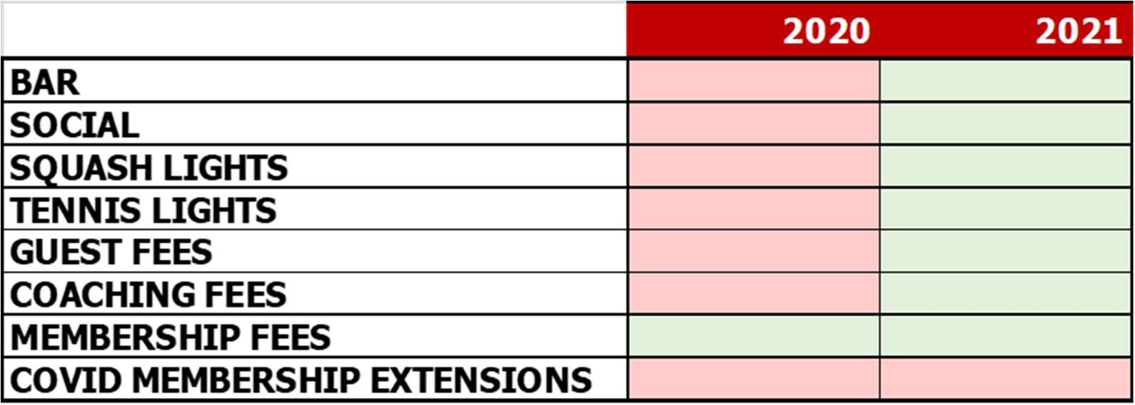

This continues to put the club in the position to deliver on the highlighted priorities for 2022 and 2023;

2022:

* Tennis floodlight upgrade
* Squash building roof replacement and refurbishment
* Club drainage risk mitigation

2023

* Men’s toilets refurbishment
* Bar refurbishment (to be confirmed)

# Membership Levels

These continue to sit at an all-time high.

|  |  |
| --- | --- |
| Adult Joint Squash | 26 |
| Adult Joint Tennis | 83 |
| Adult Joint Tennis & Squash | 12 |
| Adult Squash | 147 |
| Adult Tennis | 229 |
| Adult Tennis & Squash | 37 |
| Adult Tennis Off-Peak | 113 |
| Junior Squash (12-16 years) | 15 |
| Junior Squash (under 12) | 4 |
| Junior Tennis & Squash (12-16 years) | 28 |
| Junior Tennis & Squash (under 12) | 21 |
| Junior Tennis (12-16 years) | 34 |
| Junior Tennis (under 12) | 46 |
| Social | 18 |
| Squash & Off-Peak Tennis | 7 |
| Student Squash | 12 |
| Student Tennis | 4 |
| Totals | 856 |

Tennis Membership

The tennis peak time wait list sits at 170, we will continue to operate peak time entry on a 1-in, 1-out basis until the completion of a ‘normal’ summer season, and to enable flexibility with respect to the potential expansion of the coaching program.

Squash Membership

It was agreed that Squash membership is now full and will be capped.

* A wait list will be set up and operate on a one-in one out basis (Mel).
* The website will be updated ASAP (Peter)
* Newsletter update to be drafted (Graeme)
* Social Squash membership will now cease, the 4-5 members affected will be offered full time membership to allow them to continue to participate in 1st team matches (Graeme)
* To manage court pressure the no-opponent court cancellation policy will be extended to 3 days (Pete / Andrew Hoade)
* A squash-off peak membership package will be offered - details to be finalised (Peter / Graeme)

Other Points

It was agreed the volunteer contribution so vital for the running of the club is significantly under-represented by squash-only members. With the expansion of squash, and associated investment it is vital to increase engagement from our squash membership.

* A squash members meeting will be held end of March / Early April (Graeme)

# Investment priorities update

Squash Roof Replacement and Renovation

The committee formally signed off the sum of £90K for the replacement of the squash building roof under the as-is design. A further sum (to be confirmed) will be allocated to the refurbishment part of this project.

It was agreed that the further £60K of funding required to elevate the roof could not be prioritised through existing club revenue streams and would need to generated via long-term memberships under a similar program to that offered during the tennis clay court upgrade.

The aim is to commence and complete work this summer

Associated actions

* Confirm costing and full scope of roof replacement on as-is design (Gary)
* Review of structural engineer costs to confirm scope of raising the existing roof (Gary)
* Draft of long-term membership offers and roll-out plan (Tim / Peter / Graeme)

Tennis Floodlights

A sum of £30k has been ring fenced to complete the work this summer before the 2022 autumn / winter season. Due to experiences associated with the unsatisfactory lighting solution on courts 1&2 a consultant will be hired to propose and overall light solution for ALL courts.

Key deliverables

* Ensure full usability of courts 5-7
* Any solution must suit a members self-service framework
* On-off cycle times must be minimal / instantaneous

Associated actions

* Hire light consultant and draw up proposed solution and final costs (Tony)
* Review of self-serve lighting solutions (Tim / Danielle)
* Confirm potential membership inclusive lights fees (Tim / Danielle)

# Tennis Head Coach Updates

Alex formally starts in the role of Tennis Head Coach on 8th March. The first few weeks will focus on membership introductions and the completion of a proposed coaching program for sign off by the Tennis coaching subcommittee (Ben Kelly / Tim Bannerjee / Danelle Wade / Nick Johnson).

Initial meeting with the coaching team have been extremely positive. It was re-affirmed that club’s head coaches have the unequivocal support of the committee.

# Squash Head Coach Updates

Activities continue to go from strength to strength, with the recent handicap tournament proving a massive success. The Ladies’ Closed tournament is to be re-established and will run this month.

The cleanliness of the facilities was raised and will be addressed. Danielle is leading the charge on the appointment of a new cleaner. This should be completed early March

# Rebuilding the Social Calendar

The first meeting of the 2022 social committee was held 28th Jan

The social committee consists of:

* Sarah Dickinson (Secretary)
* Danielle Wade
* Emma Webb
* Chris Entress
* James Cornish
* Alex Collins
* James Townsend
* Christopher White
* Jegan Sivanandan
* Kyla Chapman

It was noted that despite request for volunteers, representation from squash membership remains poor.

The substantial social calendar (see below) was shared and will be included in the newsletter ASAP. Notification was given that Sarah expects to step down from the role at the end of the year, her replacement will be lined up.

It was viewed as essential to align squash tournaments with some of the activities listed on the social program.

Associated actions

* Announcement of social calendar to membership (Sarah)
* Alignment of squash tournaments and activities (Marco)

